14.59: a) The “lift” is 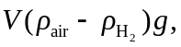 from which

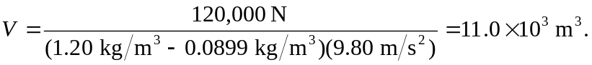

b) For the same volume, the “lift” would be different by the ratio of the density differences,

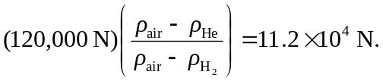

This increase in lift is not worth the hazards associated with use of hydrogen.

